- Windows Installer 3.1
First Install Windows Installer 3.1, if necessary.

- Microsoft Dot Net Framework 2.0
Please select options as described as following to install Dot Net Framework 2.0

  - On the first Welcome Screen Click “Next”

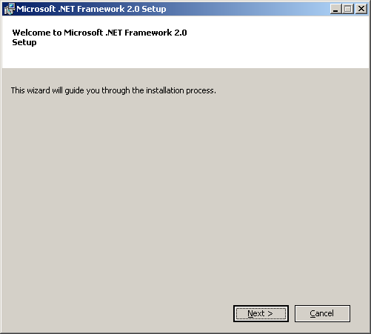

  - On the End User License Screen Click accept License terms and click on “Install”.
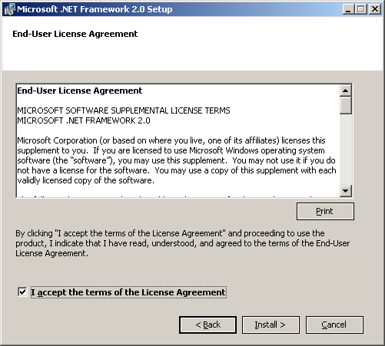

  - On the Installing Components screen wait for the setup to complete its task it will take some time to complete setup.

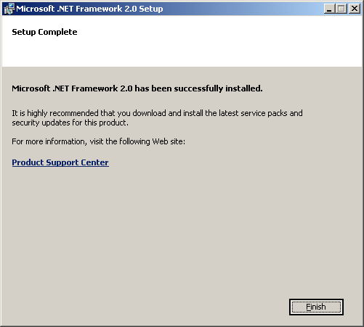

  - Click on the Finish button to complete setup.
- SQL Server 2005 Express Edition
Please select options as described as following to install SQL Server 2005 Express Edition.

  - On the End User License Screen Click accept License terms and click on “Next”.

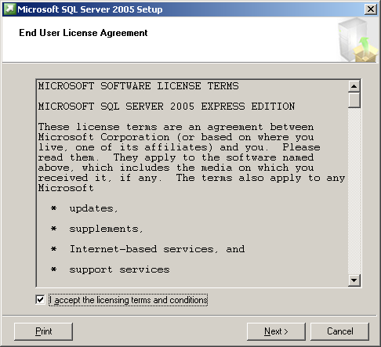

  - On Installing Perquisites screen and click on “Install” and wait for setup to complete its task.

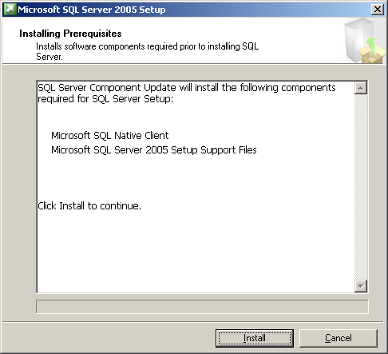

  - On Installing Perquisites screen after installation, click on the “Next”.

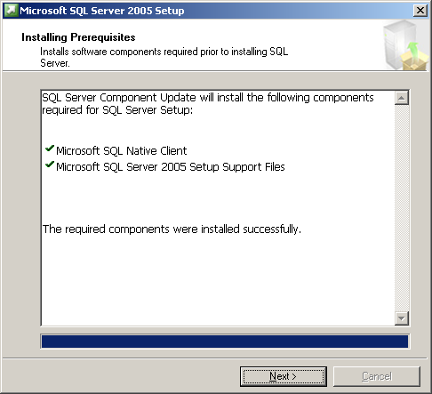
  - On Welcome Screen, click on the “Next”.

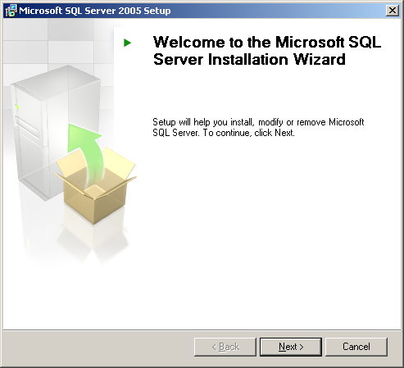

  - On System Configuration Check Screen, click on the “Next”.

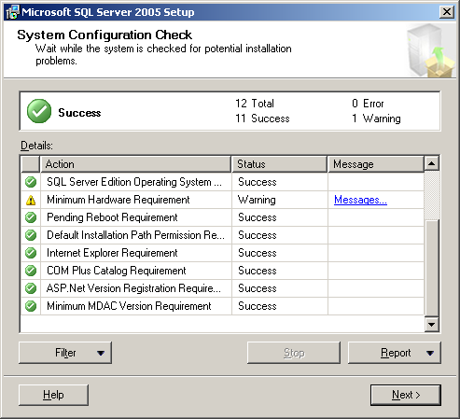
  - On Registration Information Screen, provide Name and Company information and click on the “Next”.

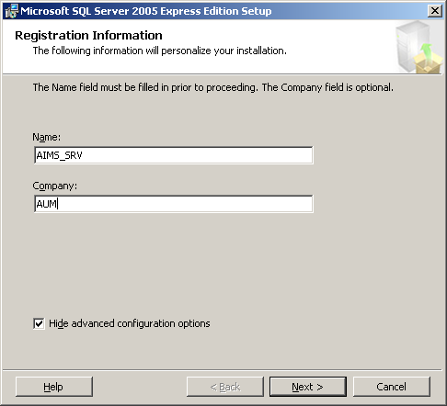

  - On Feature Selection Screen, make sure following options are selected and click on the “Next”.

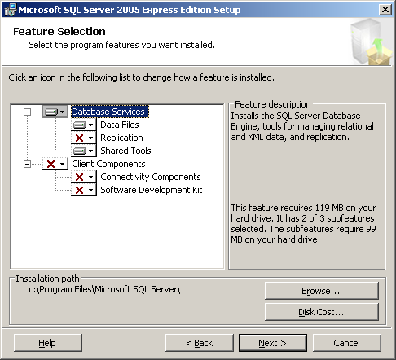

  - On Authentication Mode Screen make sure Windows Authentication Mode is selected and click on “Next”.
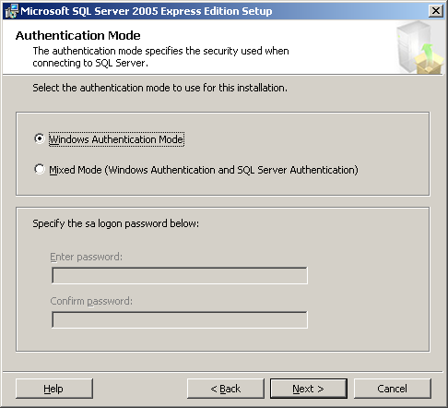

  - On Error and Usage Report Settings Screen make sure nothing is selected and click on “Next”.

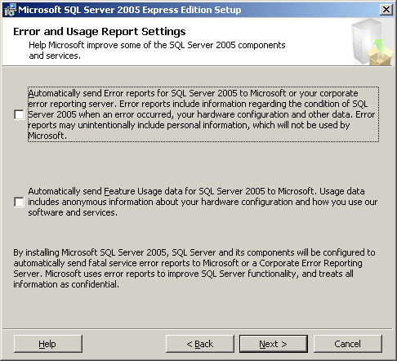
  - On Ready to Install Screen click on “Install” and wait for setup to install components.

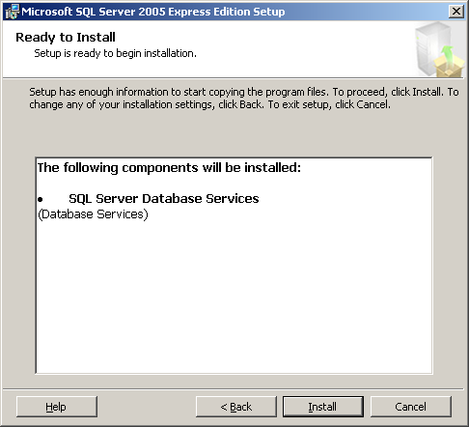

  - On Setup Progress Screen make sure all components are installed successfully and click on “Next”

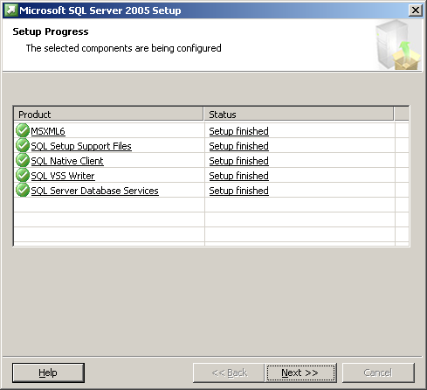

  - On Completing Microsoft SQL Server 2005 Setup screen click on “Finish” to finish the setup.

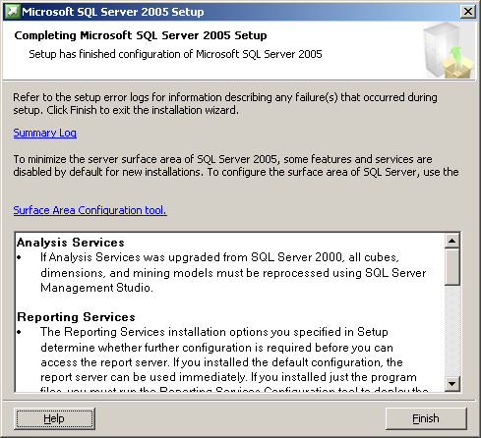

- Microsoft SQL Server Express Edition Tool Kit
Install SQL Server 2005 Express Edition Tool Kit with same options as setup steps of SQL Server Express Edition. Please make sure On Feature Selection screen following options are selected.

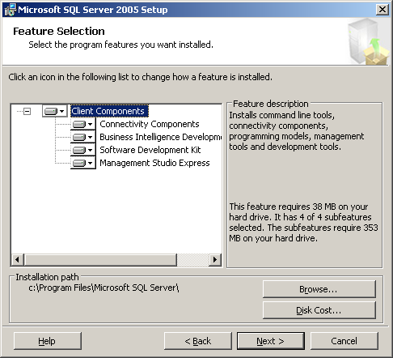

- And make sure following components are installed and Click on “Next” to Finish Setup.
